A drop in near misses at Buttskop Level Crossing in Blackheath since 2015

There was noticeable motor driver behaviour at the Buttskop Level Crossing in Blackheath during a recent safety campaign at the crossing. The level crossing attracted national media attention last month, following an incident where seven occupants of a bakkie were all killed when their bakkie collided with a train. Since Metrorail intensified its weekly safety campaigns, near misses at Buttskop are recorded to have declined as follows:

- 2015 – 45
- 2016 – 36
- 2017 – 24
- 2018 – 22

Although there has been a decrease in the near misses, some drivers continue to disobey road rules and signs. As part of implementing corrective measures on the rail-road crossing the following fines were issued:

- 9 taxi drivers were fined for overloading passengers – a fine of R400 each driver was issued = R3 600,
- 3 drivers were caught driving without valid driver’s licences – each was fined R1 000 = R3 000,
- 2 unlicensed vehicles were fined R500 each = R1 000,
- 3 drivers were driving facing oncoming traffic – each was fined R3 500 = R10 500,
- 2 inconsiderate drivers were each fined R2 500 = R5 000,
- 1 driver’s cellphone was confiscated and was charged R500,
- 1 driver without a safety belt was fined R250

A total of R24 100 fines were issued.

The recent campaign at the crossing was conducted as part of the safety calendar that is planned at the beginning of the year and is guided regional safety statistics. The Marketing & Communication department was supported by Business Risk, Customer Services, Road Safety Management, Protection Services and City of Cape Town’s Traffic Management Services. There was great support from the motorists and the surrounding community.

Below, are a few photographs taken during the campaign:
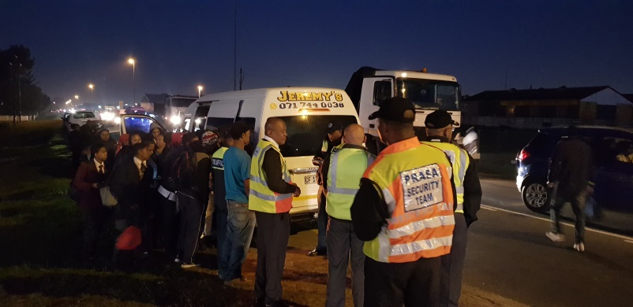  The After driving on the wrong side of the road to cut the line the taxi on inspection from the traffic department the taxi and the driver were found to not have license and registration | 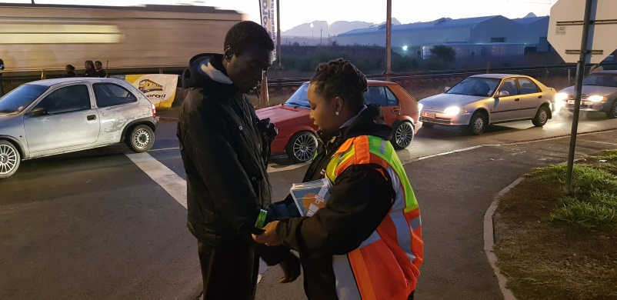  Road Traffic Management was present as well to support Metrorail’s safety campaign - they interacted with the pedestrians, urging them to be visible with reflective clothing or items e.g. armbands
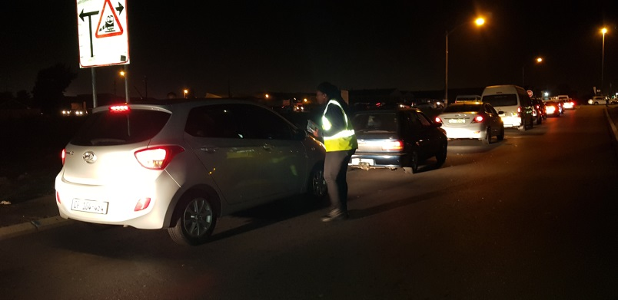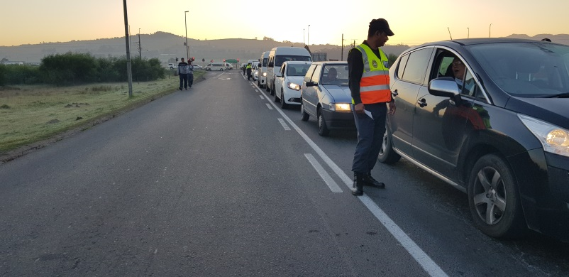
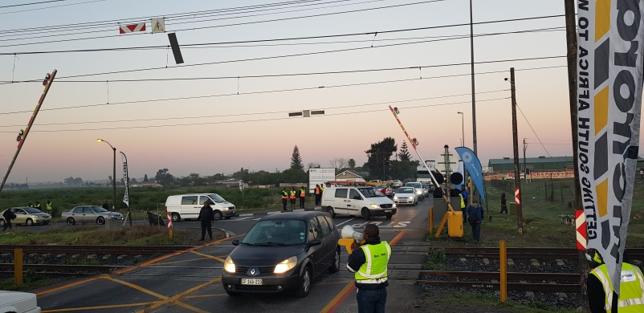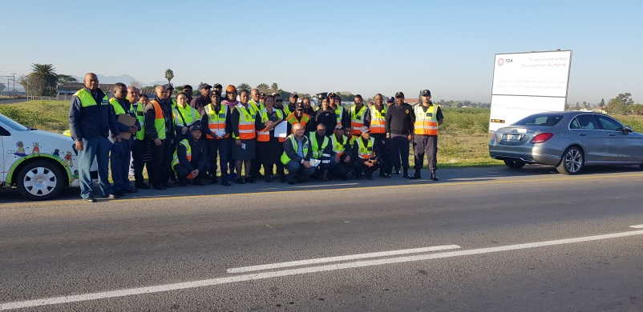
Buttskop Level Crossing is one of the busiests crossings in Area North - the team managed to interact with most of the motorists and pedestrians on safety of the level crossing

