International Level Crossing Awareness Day (ILCAD)

7 June 2012, Buenos Aires, Argentina

Level crossings as an important part of the relationship between the railway and their urban or rural environment, has always been a problem with difficult solutions, and was rarely dealt in a serious way.

In particular, from 1993 the increase of accidents soared with the disappearance of the long-distance passenger rail transport throughout the country. That was a consequence of the destruction of the railway transport system, which is safe, controlled, efficient and ecological, and that was replaced by somewhat an anarchic, unsafe, polluting, inefficient and dangerous mode. It also brought an additional consequence, loss of consciousness and respect for the presence of the railway. The sharp growth in the automotive fleet and in the economic dynamics has increased the problem. To stop this insane race to the death it is necessary to return to life, which is not otherwise to recover our railways and tramways, safe and reliable systems, of very low environmental impact, low energy consumption, very low accident rate, highly reliable in terms of control of movement and operational safety. Everything else (driver education, road checks, etc.) are essential measures, but that will be insufficient and incapable of resolving the underlying problem.

"Stop, look, listen" must be the catch phrase, both for drivers of motor vehicles approaching a level crossing, and for decision-makers concerning transport in Argentina looking to the future. Change the history isn't easy but not impossible. It must just be done.

The obligation of road vehicles is to stop at a level crossing, there are no excuses, whatever signage existing, watch (and listen to) and thus ensure the crossing.

Several decades ago the Argentinean Railways made improvements in safety regulations, but not too much in practical applications, except for some special cases such as the Siemens signage on a line from the North of Buenos Aires. In the last 6 years a major work of replacement of level crossings by different level passes took place in Argentina, with some 40 works in several parts of the country, especially in the metropolitan area of Buenos Aires, where concentrates the largest population and traffic of the country. Road safety campaigns through civilian organizations such as the ISEV - Road Safety Institute and the Association Luchemos por la Vida (Fight for life) were also realised.

Some railways, such as FerroExpreso Pampeano, Nuevo Central Argentino and UGOFE, have materialised good solutions in many level crossings with appropriate technical solutions. Ferrovías has managed to maintain in perfect conditions the excellent old automatic GRS barriers systems, properly updated.

To contribute to public awareness on level crossings, the IAF has published several articles and also cooperates with the Buenos Aires Regional Faculty of the Universidad Tecnológica Nacional (National Technological University) in organizing the first ILCAD Seminar in Argentina.

Buenos Aires, May 2012
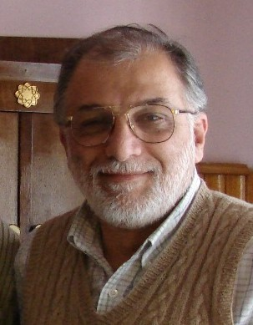
Pablo Martorelli
President
INSTITUTO ARGENTINO DE FERROCARRILES (IAF)
ARGENTINE INSTITUTE OF RAILWAYS
www.iaf.org.ar (in reconstruction)
pmartorelli@iaf.org.ar

